

Mini Project Report of DBMS Lab on

**Library/Book Management System**

SUBMITTED BY

|  |  |  |
| --- | --- | --- |
| **S. No.** | **Name of Student** | **Roll Number** |
| 1. | Himanshu Gaikwad | TECO2425A006 |
| 2. | Ashwin Patil | TECO2425A008 |
| 3. | Prashant Shejwal | TECO2425A018 |

Under the guidance of

**Mrs. Dhanashree Phalke**

In partial fullfillment of the requirements for

Bachelor’s Degree in Computer Engineering of

**SAVITRIBAI PHULE PUNE UNIVERSITY**

**[2024 – 2025]**

Department of Computer Engineering

D. Y. PATIL COLLEGE OF ENGINEERING, AKURDI, PUNE 411044

## Description: DYPCOE Akurdi Pune (@DYPCOEAK) | Twitter

## D. Y. Patil College of Engineering Akurdi, Pune-411044

**Department of Computer Engineering**

**CERTIFICATE**

This is certify to **Himanshu Gaikwad(TECO2425A006), Ashwin Patil(TECO2425A008), Prashant Shejwal(TECO2425A018)** have satisfactorily completed the mini project work entitled **“Library/Book Management System”** which is a bonafide work carried out by them under the supervision of **Mrs. Dhanashree Phalke** for the partial fulfilment of requirements of Savitribai Phule Pune University, for the award of the degree of Bachelors of Engineering (Computer Engineering) for the academic year 2024-25.

**Mrs. Dhanashree Phalke Dr. Mrs. Madhuri A. Potey**

(Mini Project Guide ) (HOD Computer)

Place: Pune

Date:16-10-2024

# ACKNOWLEDGEMENT

With immense pleasure, we present the mini project report as part of the curriculum of the T.E. Computer Engineering. We wish to thank all the people who gave us an unending support right from when the idea was conceived.

We express sincere and profound thanks to **Mrs. Dhanashree Phalke** and HOD, **Dr. Mrs. M.A. Potey**, who were ready to help with the most diverse problems that we encountered along the way. We express sincere thanks to all staff and colleagues who have helped directly or indirectly in completing this project work successfully.

|  |  |  |  |
| --- | --- | --- | --- |
| **S. No.** | **Name of Student** | **Roll Number** | **Sign** |
| 1. | Himanshu Gaikwad | TECO2425A006 |  |
| 2. | Ashwin Patil | TECO2425A008 |  |
| 3. | Prashant Shejwal | TECO2425A018 |  |

# Table of Contents

|  |  |  |
| --- | --- | --- |
| **S. No.** | **Chapters** | **Page No.** |
| 1. | Abstract | 5 |
| 2. | Introduction | 6 |
| 3. | Hardware and Software Requirements | 12 |
| 4. | ER Diagram | 13 |
| 5. | GUI & Source Code | 14 |
| 6. | Conclusion | 18 |

## 1.Abstract:

The Library Management System is designed to streamline the daily operations of a library, making it easier to manage books, and handle member information. By automating key tasks like searching for books, issuing them, and managing returns, the system offers a user-friendly experience for both librarians and library users. Its goal is to reduce manual effort by providing essential features such as filtered book searches (by title), membership management, Issue and returns of books as well as to reduce paper work .

Developed using Python and MySQL, the system ensures that library data is secure, easily accessible, and well-organized, while significantly cutting down on paperwork. It consists of various functionalities such as Issue and return of books , searching of books , adding and deletion of book in library database .

Throughout the project, we used a modular development approach, allowing room for future improvements and easy integration with other systems. In the end, this system not only simplifies library management but also boosts efficiency, reduces errors, and enhances the overall experience for both staff and members.

## 2.Introduction:

## Libraries have always played a vital role in providing access to knowledge and information. However, managing a library can be a complex task, from keeping track of book inventories to handling member records and lots of paperwork . Doing all of this manually can be time-consuming, prone to errors, and inefficient. With the rise of digital tools, there’s an opportunity to make this process smoother and more organized.

## This project focuses on developing a Library Management System that simplifies these tasks by using Python’s GUI library Tkinter for the front end and Python for backend . It uses MySQL for the database . Python, known for its simplicity and readability, ensures a user-friendly interface for librarian . MySQL, on the other hand, provides a robust and secure way to store and manage large amounts of data, such as book details, member information, and various CRUD operations .

It helps the Librarian to keep digital record for the issue and return of book , addition and deletion

of books in database , Searching of Books , Keeping record of Students who hold the books .

## 2.1 Functional Overview

## 

The **Library Management System** has variety of functionalities that enable users to interact seamlessly with books listing , Issue and Returns and Record of Students who hold the books . Below is a breakdown of the core features:

#### 1. User Authentication & Authorization

* **Login** : Admin can create an account by Login with a username, email, and password.

.

#### 2. Book Cataloging and Search

* **Add Books** : Admin can add books to the Library Database along with its book id , quantity, book name , author , edition and price.
* **Search** : Admin can easily search for books in database to look for available books and its quantity.
* **Book Holder**: Admin can look for record of all members who have issued books .

#### 3. Book Issuance and Return

* **Book Issue** : This allows Librarian to Issue the book to a student by their name , roll no & branch .When single book is remaining it doesn’t allow it to issue .
* **Book Return** : This allows the Librarian to manage book returns and delete name of member from current book holders record .

#### 4. Backend and Database Operations

* **MySQL** : The back end, powered by MySQL, securely stores all data, including book details, user information, and transaction histories. This ensures that large volumes of data are handled efficiently and that all records are preserved for future reference. . All data operations, including creating, updating, and deleting records, are managed efficiently using MySQL queries.

#### 

## 2.2 Technologies Used

The **Library Management System** is created using following Frontend , Backend technologies and Database .

#### 1. Backend Technologies

* **Python** :
  + **Python**  is use in the backend for all functionalities . Python is very powerful language which can be used in almost every field . It use PyMySQL to connect with database .

#### 2. Frontend Technologies

* **Python (Tkinter ) :**
* The GUI is created using the Python’s popular GUI library called Tkinter .
* **Python (Pillow)** :
* The Images and Icons are managed using Python’s Pillow library .

#### 4. Deployment and Development Tools

* **Git and GitHub**:
  + **Git** is a version control system used to manage the source code of the project.
  + **GitHub** serves as the remote repository where the project code is hosted, allowing collaboration .

#### 5. Database

* **MySQL** : The back end, powered by MySQL, securely stores all data, including book details, user information and book holder details ensures that large volumes of data are handled efficiently and that all records are preserved for future reference. . All data operations, including creating, updating, and deleting records, are managed efficiently using MySQL queries.

## 3.Hardware & Software Requirements

* **Hardware**
  + Processor: Intel i3 or above
  + RAM: 4GB or higher
  + Storage: 100GB or more (for development purposes)
* **Software**
  + **Backend**: Python
  + **Database**: MySQL
  + **Frontend**: GUI using Tkinter and custom Tkinter , Pillow (PIL) libraries of Python
  + **Tools**:
    - Code Editor: Visual Studio Code
    - Version Control: Git and GitHub
  + **Operating System**: Any OS which support Python (Windows, macOS, Linux)

## 4.ER- Diagram

* 1. **Entity-Relationship Model (Planning)**

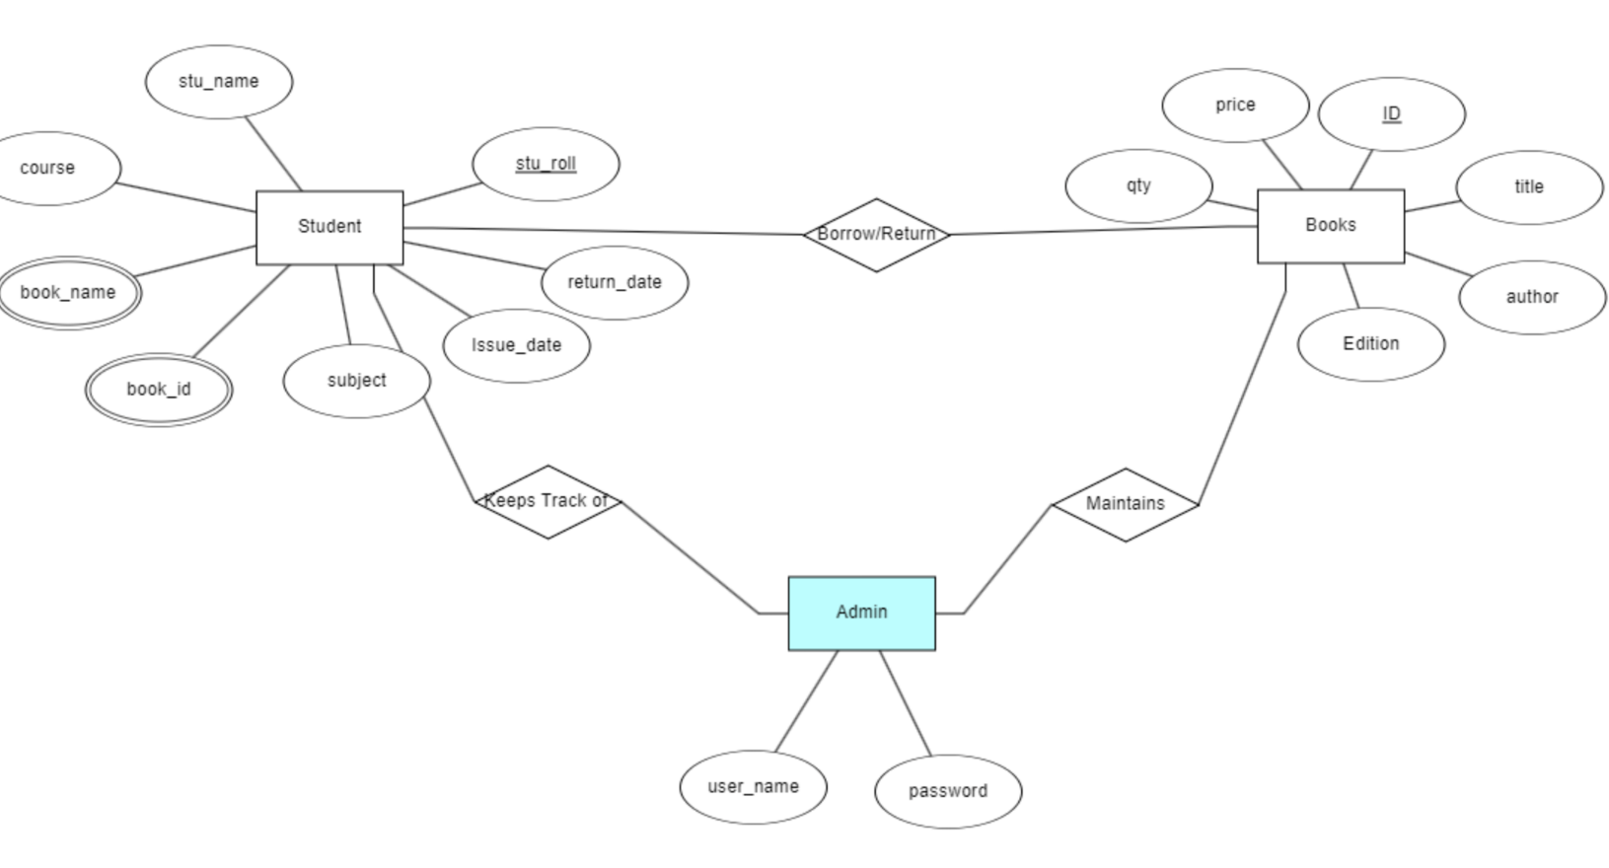

Fig1.Library Management System

## Database Schema

**1.Borrower List**

|  |  |  |  |
| --- | --- | --- | --- |
| **Field Name** | **Type** | **Description** | **Required** |
| **book_id** | INT | Unique Identifier | Yes |
| **book_name** | VARCHAR | Name of Book | Yes |
| **stu_roll** | INT | Roll No of Student | Yes |
| **stu_name** | VARCHAR | Name of Student | Yes |
| **course** | VARCHAR | Name of Course | Yes |
| **subject** | VARCHAR | Name of subject | Yes |
| **issue_date** | DATE | Date of Issue of Book | Yes |
| **return_date** | DATE | Expected Date of Return | Yes |

**Table1**

**2. Book List**

|  |  |  |  |
| --- | --- | --- | --- |
| **Field Name** | **Type** | **Description** | **Required** |
| **book_id** | INT | Unique Identifier | Yes |
| **book_name** | VARCHAR | Name of Book | Yes |
| **Author** | VARCHAR | Author of Book | Yes |
| **Edition** | VARCHAR | Edition of Book | Yes |
| **Price** | INT | Price of Book | Yes |
| **Qty** | INT | Quantity of Book | Yes |

**Table 2**

**3. Admin**

|  |  |  |  |
| --- | --- | --- | --- |
| **Field Name** | **Type** | **Decription** | **Required** |
| **User_name** | VARCHAR | Admin Username | Yes |
| **password** | VARCHAR | Password | Yes |

**Table 3**

**5.GUI & Source Code**

* + **User Interface (UI)**:The System has simple user friendly GUI . It consists of Simple but necessary CRUD operations that are required in Library Management System such as Add Books , Issue and Return of Books . Searching , and list of book holders .

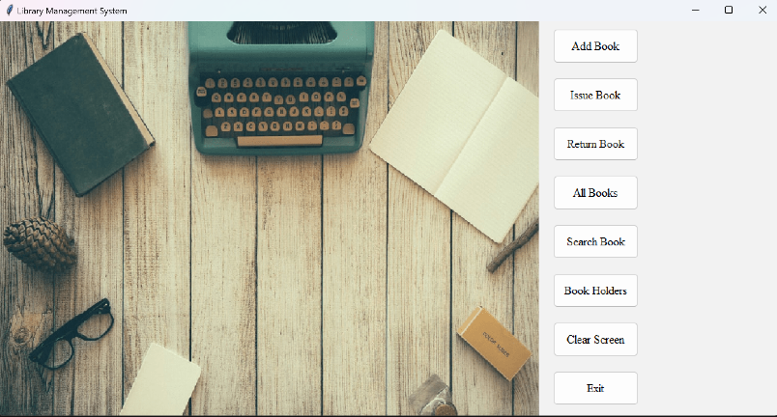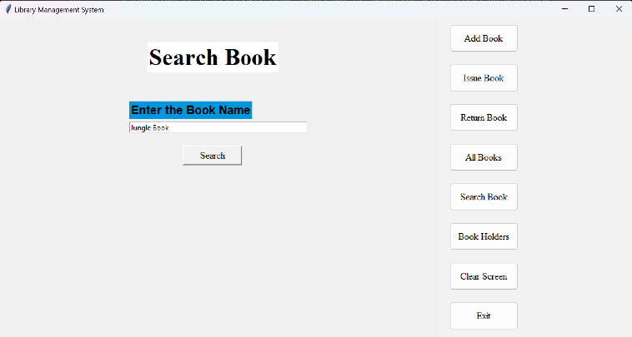 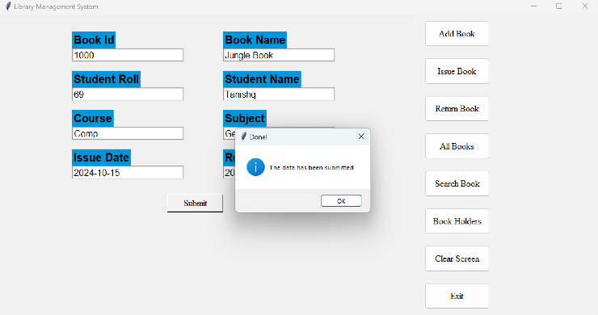

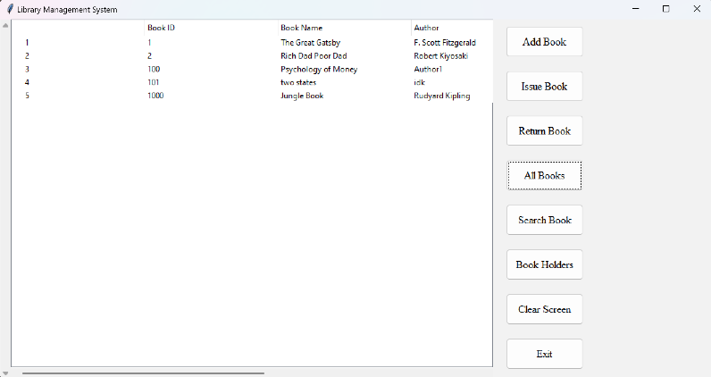 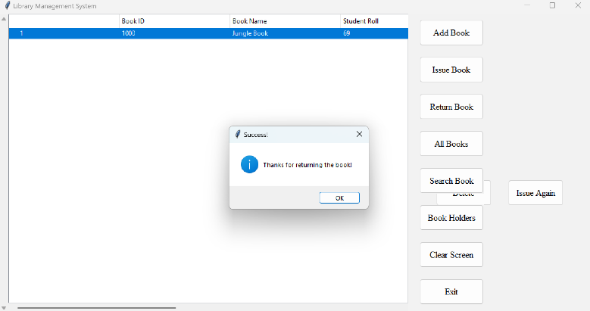 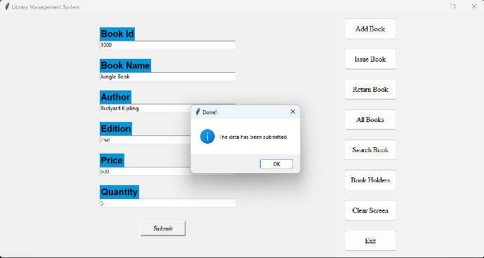

* + **Key Functionalities in Source Code**:
    - **CRUD Operations**: The system allows creating, reading, updating, and deleting Book listing and Book Holders . It helps us to search for particular book and member .
    - **Front End & Backend** : Both Frontend and Backend uses Python . For frontend we use Python’s GUI library such as Tkinter and for images we use Pillow library .
    - **Database** : Database consists of MySQL . Its queries helps for easy CRUD operations.
* **Source Code:**
* 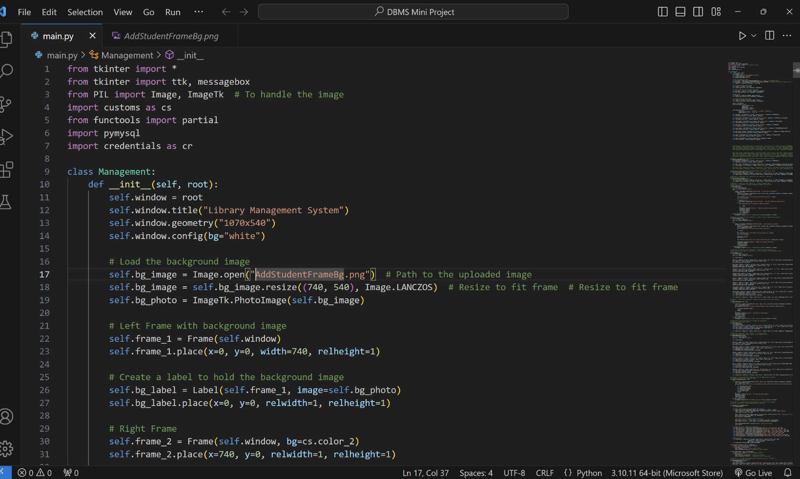

Fig 2. Source Code Snapshot

## 6.Conclusion

The **Library Management System** developed in this project provides a simple yet effective solution to the common challenges faced by libraries. By combining **Python** for the front end with **MySQL** for the back end, the system delivers an intuitive interface and a robust data management platform, making it easier for librarians and members to interact with library resources.

## In conclusion, this project demonstrates how technology can improve the efficiency of everyday library operations, making it easier for staff to manage resources and for members to access them. The system not only simplifies processes but also creates a more user-friendly and organized library experience for everyone involved.